**Arithmetic/Logical Unit**

In this lab you will design a simple digital circuit called Arithmetic/Logical Unit (ALU) using some of the combinational building blocks. Along the way, you will use DEEDS tool to enter a schematic and simulate your design.

We need the following components:

* **2-bits Multiplexer**
* **4-bits Multiplexer**
* **Full Adder**
* **Ripple Carry Adder**

Then, you will be asked to remove the Ripple Carry Adder and to use a Carry-Lookahead Adder.

**2-bits Multiplexer**

A 2-bits multiplexer (mux) is a device that choose an output among several possible inputs, based on the value of a select signal. A 2:1 multiplexer has two data inputs and one output and a select signals.

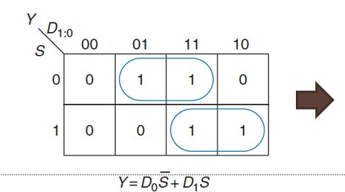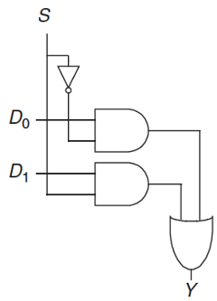

Design the circuit using Deeds and simulate it

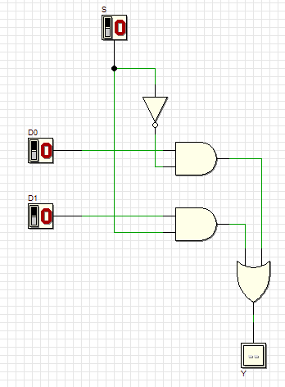

Save the file as mux_2_bits.pbs

Save the logic circuit as a **block** to reuse it: Click on “File-> New Block”

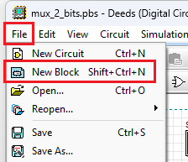

Copy the circuit into the new window and replace the input and the output with the block signal Save the block as mux_2_bits.cbe

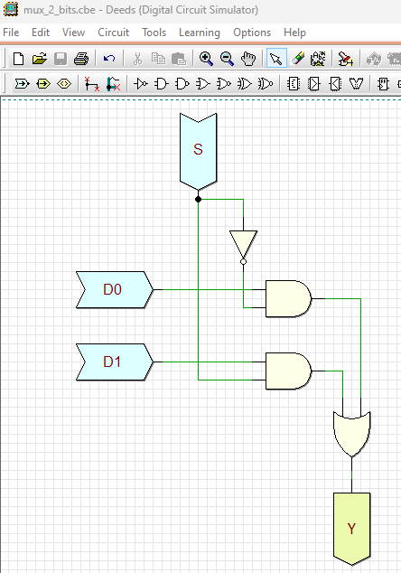

To edit the block view: View-> Show Symbol Editor

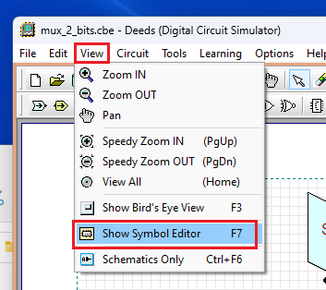

Change the view as the figure below (it may be necessary to expand the figure to move the control signal up)

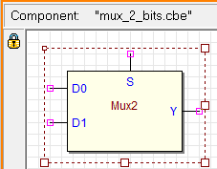

**Mux 4 bits**

A 4:1 multiplexer has four data inputs and one output and two select signals are needed to choose among the four data inputs. It can be built using sum-of-product logic, or multiple 2:1 multiplexer

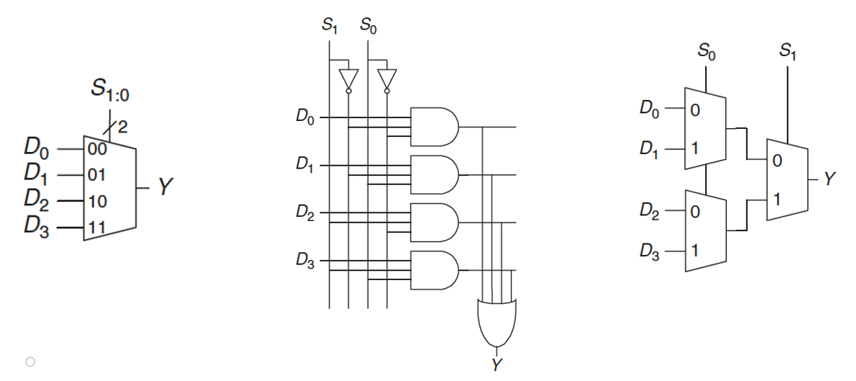

Create the logic circuit mux 4 bits :

Open new circuit => “file -> new circuit”

Check that the file of the new circuit end with .pbs

Design the full schema of the 4-bits multiplexer and simulate it

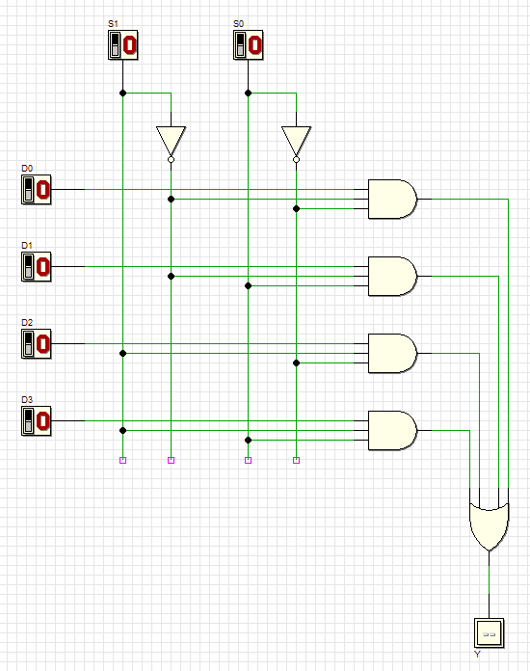

Create a block also for this component (“File->New Block”) and replace the input and the output with the block signal. Save the block as mux_4_bits.cbe

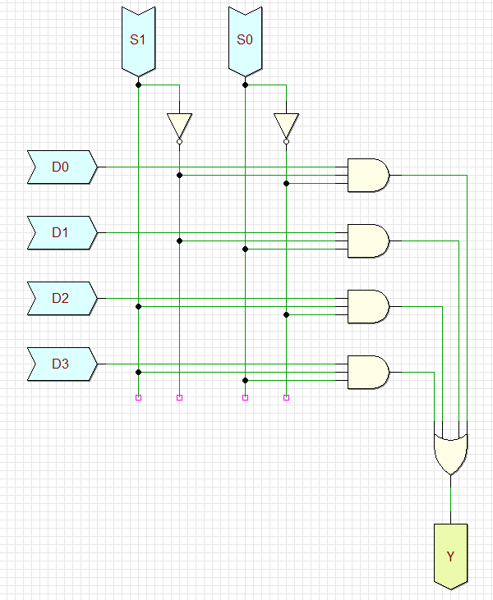

To edit the block view: View-> Show Symbol Editor



Change the view as the figure below (it may be necessary to expand the figure to move the control signal up)

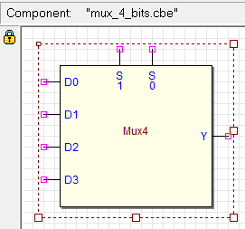

**Full Adder**

Addition is one of the most common operations in digital systems.

We can optimize the Carry Out:

Design using DEEDS this optimized circuit of a full adder and save as FullAdder.pbs

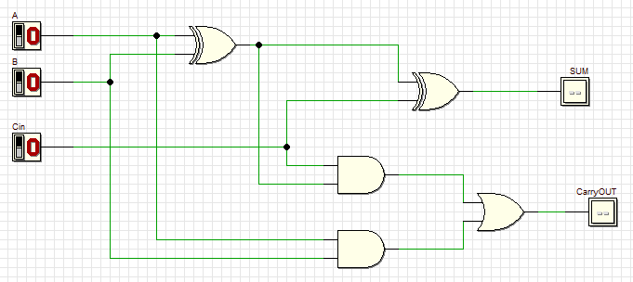

Create the block of the Full Adder and save it as FullAdder.cbe

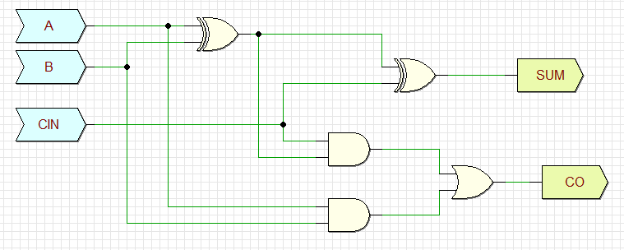

Change the view as the figure below

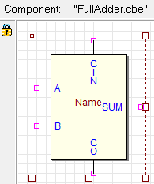

**Ripple Carry Adder**

A N-bit adder that sums two N-bit inputs and a carry in to produce an N-bit result S and a carry out. It can be implemented as a Ripple Carry Adder (Cout of one stage acts as the Cin of the next stage)

Design a 2-bits Ripple Carry Adder. Import the 1-bit Full Adder block (FullAdder.cbe) into A new circuit using the “Custom Components”icon of DEEDS toolbar

Select the file FullAdder.cbe and copy it into the circuit.

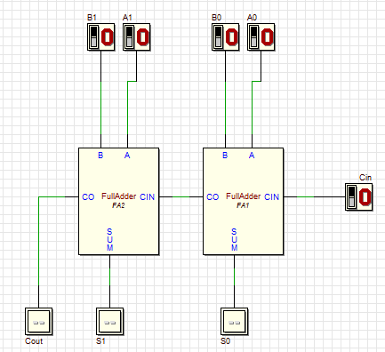

Now we can put all together to design a complete ALU

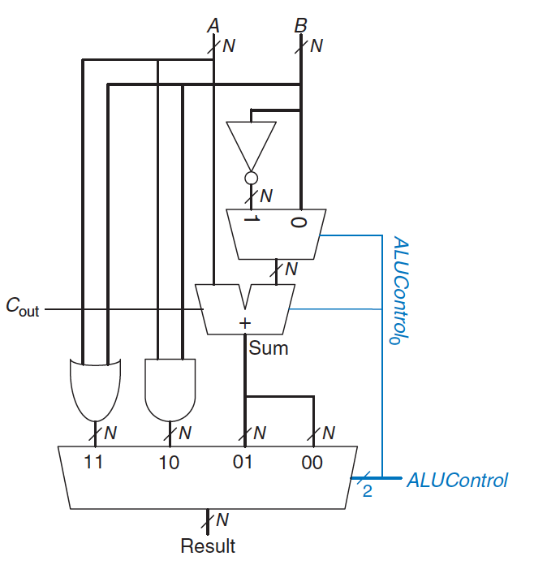

First, a simple version with 1-bit input A and B and 2-bit control signal. We import the components we have developed before (mux_2_bits.cbe, FullAdder.cbe and mux_4_bits.cbe) into the circuit to create the one-bit ALU.

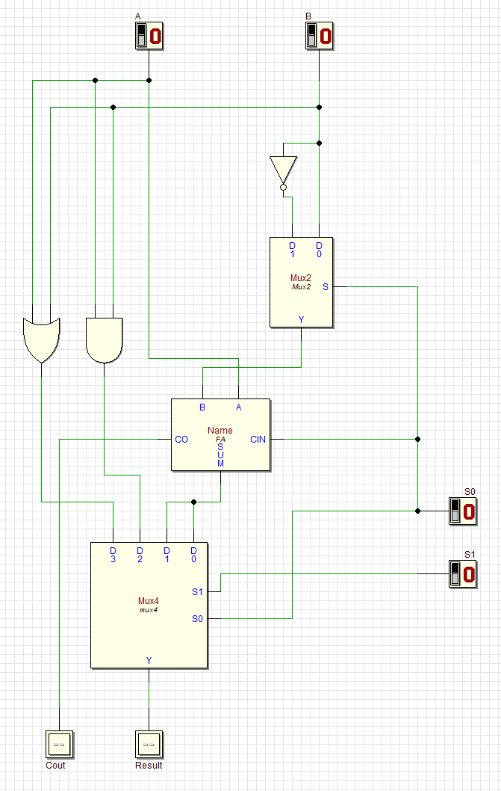

Now, we can design a more complex version with 8-bits inputs and 2-bits control signal

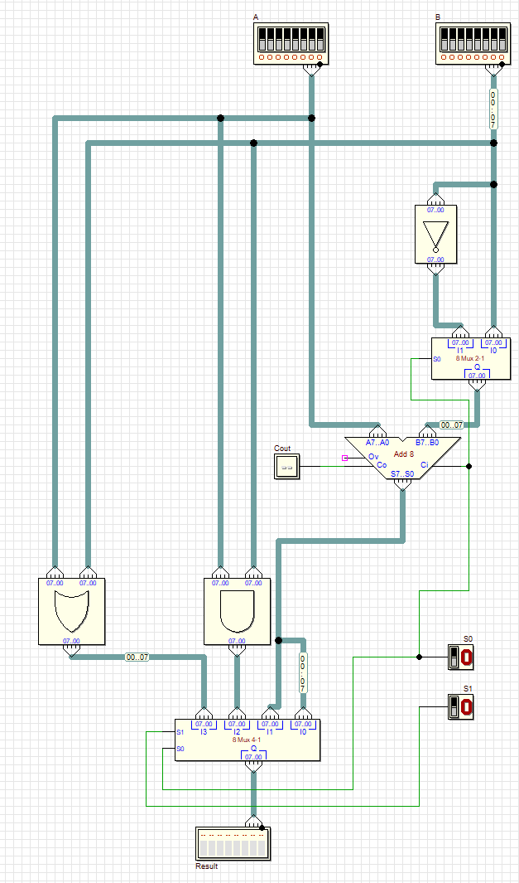

Finally, as an exercise, you can try to design a different adder implementation (with a Carry-Lookahead Adder) and substitute the one on the 8-bit ALU.

